**Project Name:**

**Prediction of the Compressive Strength of fiber reinforced concrete**

The study involves testing of cubic concrete samples with various mixing proportions and water cement ratios. The results showed that (for mixing proportion 1:1.5:3) the lower the water-cement ratio, the higher is the compressive strength. Also, with low percent of addition will significantly increase the compressive strength with the increasing of percentage of addition the compression strength decreases.

Inputs:



***Exploratory Data Analysis:***

As the algorithm packages used for Data Analysis are (Numpy , Pandas , Matplotlib , Seaborn , Sklearn).

***Normalizing Input and Output Data Set:-***

Normalization of input and output data sets within a uniform range before they are applied to the neural network are essential to prevent larger numbers from overriding smaller ones, and to prevent premature saturation of hidden nodes, which impedes the learning process. The limitation of input and output values within a specified range are due to the large difference in the values of the data provided to the neural network. In this study we normalize the input and

output parameters. That equation gives the required results with a certain mean square error.

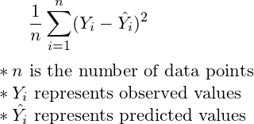

***Number of Hidden Layers and Nodes in Each Hidden Layer:-***

The number of hidden layers and the number of nodes in one hidden layer are not straightforward to ascertain. No rules are available to determine the exact number. However, the choice of the number of hidden layer and number of nodes in the hidden layer depends on the network application. Although using a single hidden layer is sufficient in solving many

functional approximation problems, some problems may be easier to solve with a two hidden layer configurations. The number of nodes in the hidden layer is selected according to the following rules:

1) The maximum error of the output network parameters should be as small as possible for both training patterns and testing patterns.

2) The training epochs (number of iterations) should be as few as possible. In the present work the network is tested with one and two hidden layer configurations with an increasing number of nodes in each hidden layer(s).

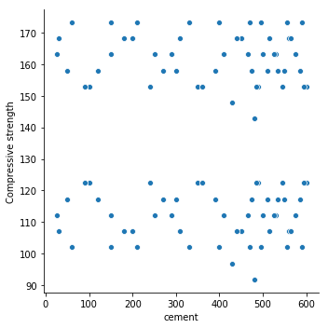

**Summary Stats :**

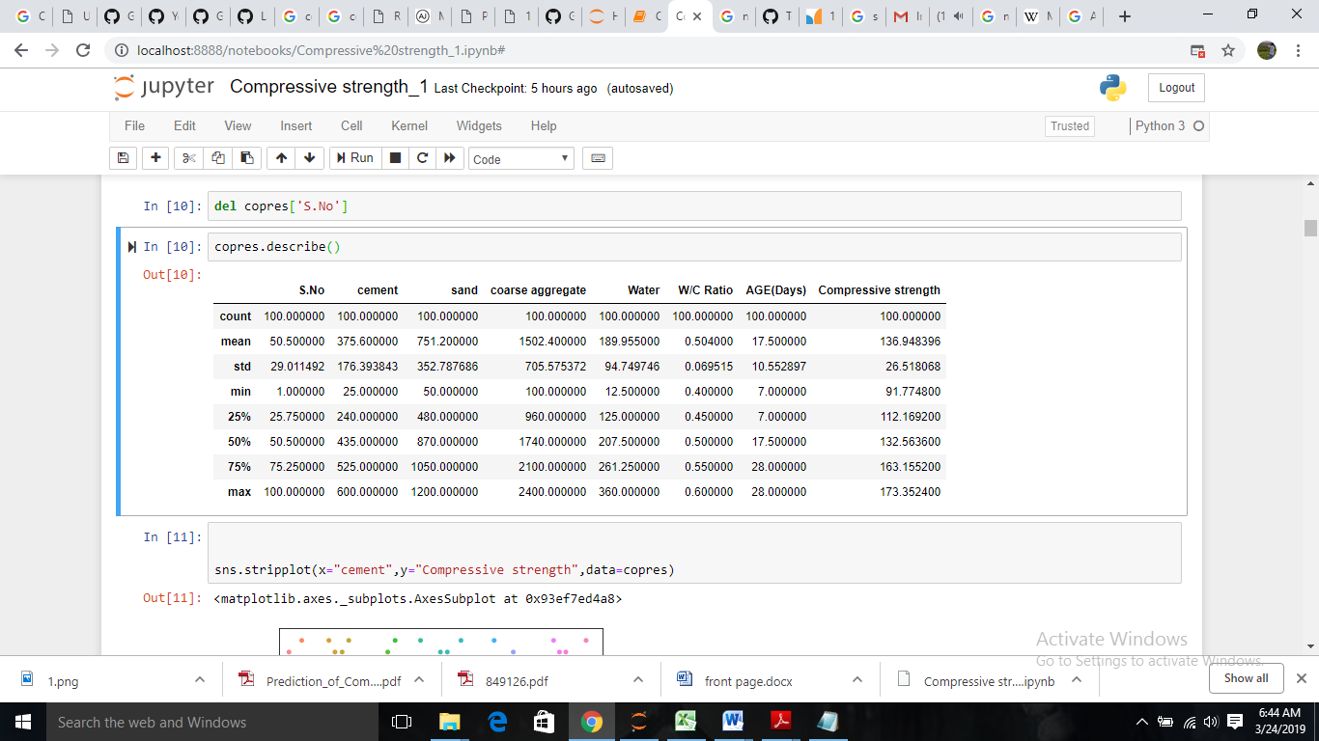

**Surface Plot:**

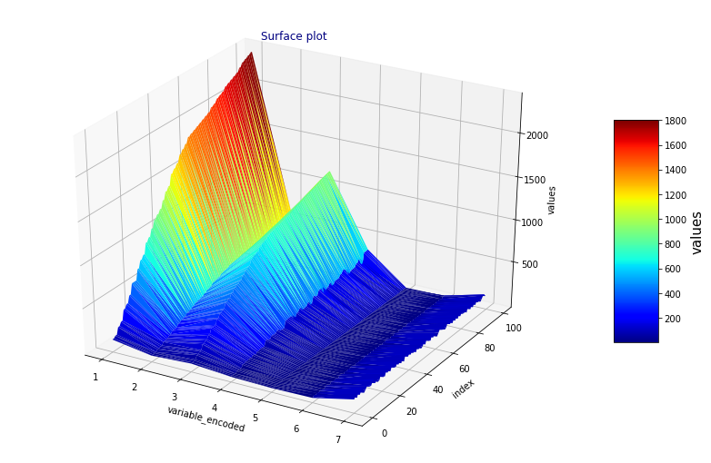

**Variables Summary:**

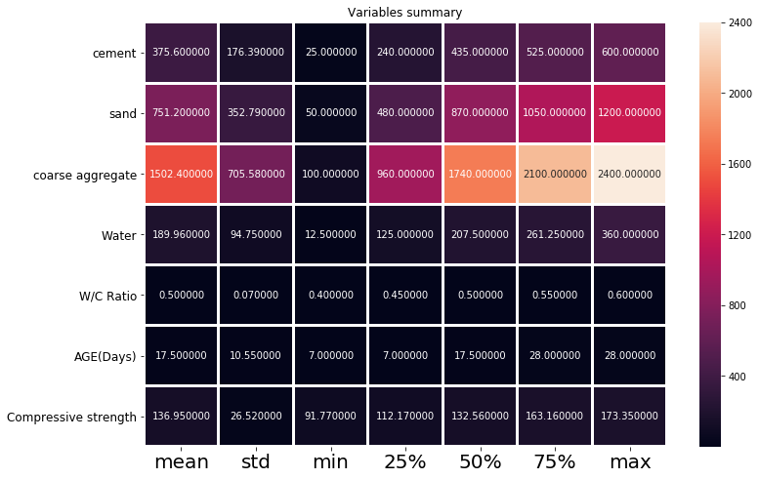

**Compressive Strength Distribution:**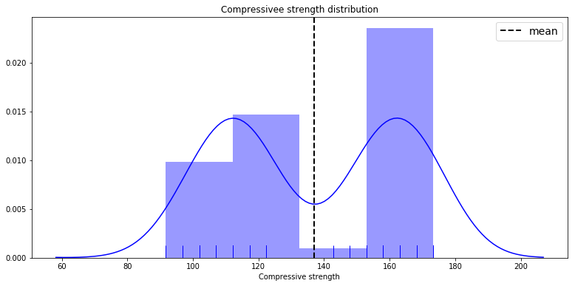

**Correlation between variables:**

